1. **How many types of conditions are available in conditional formatting on Excel?**

There are 5 types of conditional formatting visualizations available.

* Background Color Shading (of cells)
* Foreground Color Shading (of fonts)
* Data Bars
* Icons (which have 4 different image types)
* Values

1. **How to insert border in Excel with Format Cells dialog?**

1. Select one or more cells to which you'd like to add borders.

2. Open the Format Cells dialog box by doing one of the following:

* Click the down arrow next to the Borders button, and then click More Borders at the bottom of the drop-down list.
* Right click the selected cells and choose Format Cells… from the context menu.
* Press Ctrl+1 shortcut.

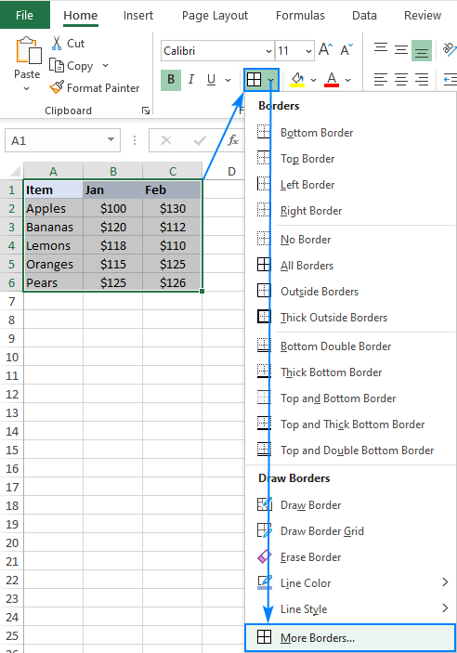

* 1. In the Format Cells dialog box, switch to the Border tab and choose the line style and color first. And then, either use Presets to add the outside or inside borders or construct the desired border by selecting individual elements such as border top, bottom, right or left. The preview diagram will reflect the changes immediately.
  2. When done, click OK.

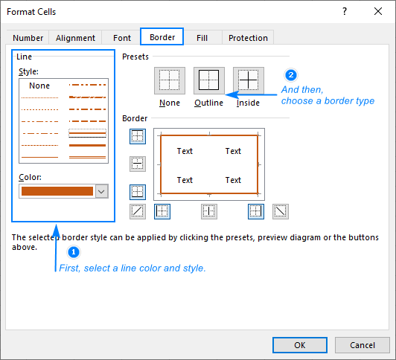

1. **How to Format Numbers as Currency in Excel?**
   1. Select the cells that you want to format and then, in the Number group on the Home tab, click the down arrow in the Number Format box.
   2. Choose either Currency or Accounting.
2. **What are the steps to format numbers in Excel with the Percent style?**

On the **Home** tab, in the **Number** group, click the icon next to **Number** to display the **Format Cells** dialog box.

In the**Format Cells** dialog box, in the **Category** list, click **Percentage**.

In the Decimal places box, enter the number of decimal places that you want to display. For example, if you want to see 10% instead of 10.00%, enter 0 in the Decimal places box.

1. **What is a shortcut to merge two or more cells in excel?**

Step 1: Highlight the two adjacent cells you want to merge

Step 2: Under the **Home**tab, click the 'Merge' icon and choose 'Merge Cells'.

Step 3: That's it! You've merged the cells.

1. **How do you use text commands in Excel?**

Select the column, or range where you'll be putting the values, then use CTRL+1 to bring up the Format > Cells dialog and on the Number tab select Text. Now Excel will keep your leading 0's. If you've already entered data and Excel has removed your leading 0's, you can use the TEXT function to add them back.

**Format text:**A text string that defines the format...

**Value:**A numeric value that you want to be con..